# Lab 8: Arrays (2)

## Objectives:

To understand the syntax of character array, declaration, assignment and initialization

To learn to write programs to model repetitive data using arrays

## Tasks:

1. Write a program that initializes a string and finds how many times a substring (entered by user) appears in it. The size of substring must be less than or equal to the size of string.

Note: “is” is a substring of “This is my bigger string and it is c plus plus string”. The substring appears 2 times in the string.

1. Take a set of N students’ examination marks (in the range 0 to 100) as input, Formulate a program that makes a count of the number of students that passed and failed the examination separately. A pass is awarded for all marks of 50 and above. Also display the minimum, maximum and average score.
2. Write a program that uses functions to perform the following operations:
3. Insert sub-string into main string from given position.
4. Delete n Characters from a given position in given string.

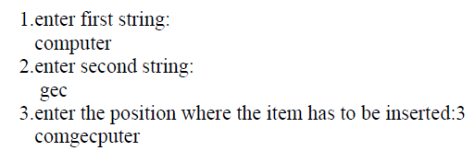**Sample Output:**

1. Write a program that takes two arrays as input and find the sum of all the elements of both the arrays and displays which array has the higher sum value.
2. Write a program that takes a string as input. If the character is upper case convert it into lower case and if the character is lower case then convert it in to upper case.